Testing API using POSTMAN

GET method for <http://127.0.0.1:5000/stocks/SEF>

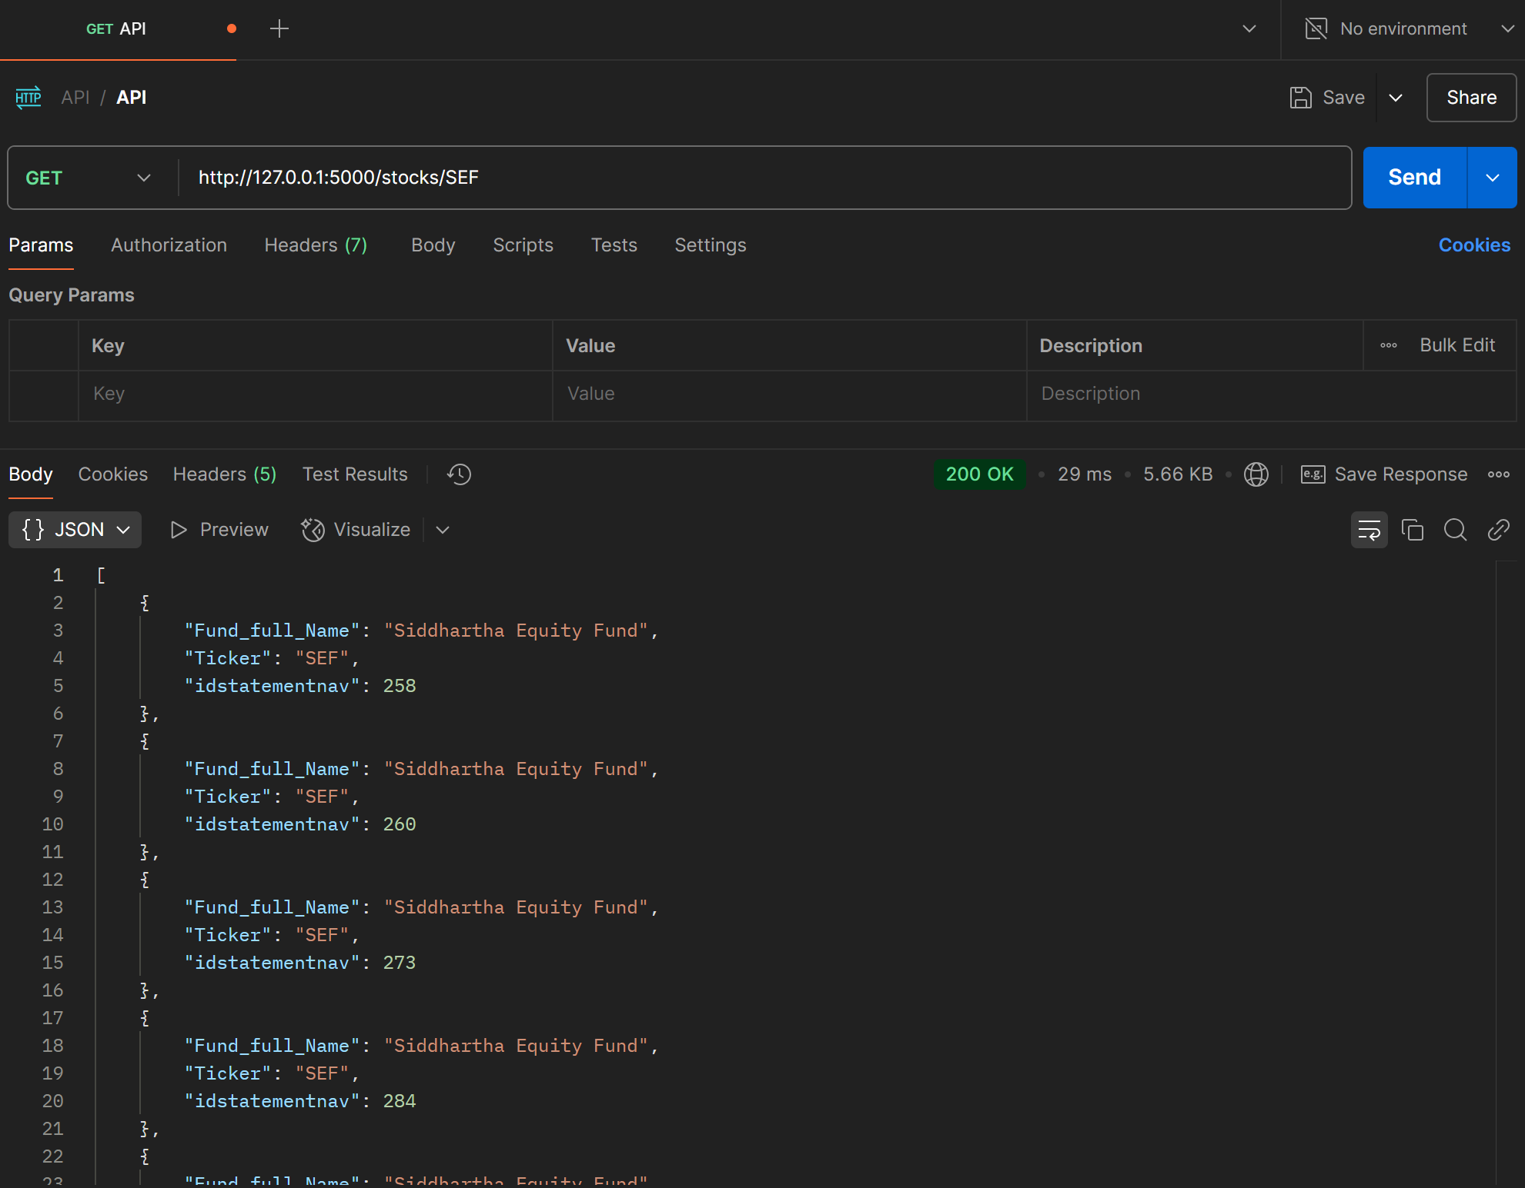

Testing API using POSTMAN

POST method for <http://127.0.0.1:5000/stocks/NMB50>

